Challenge sample 1

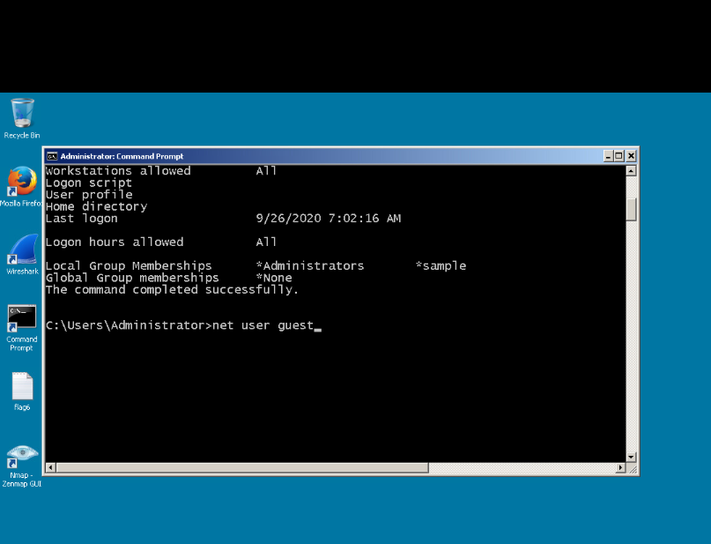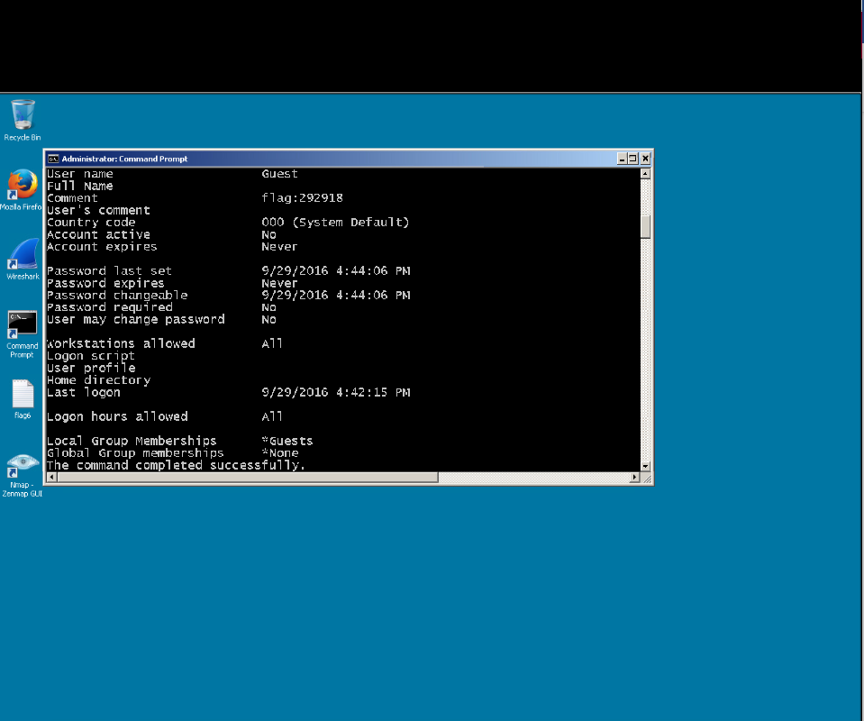Challenge 2

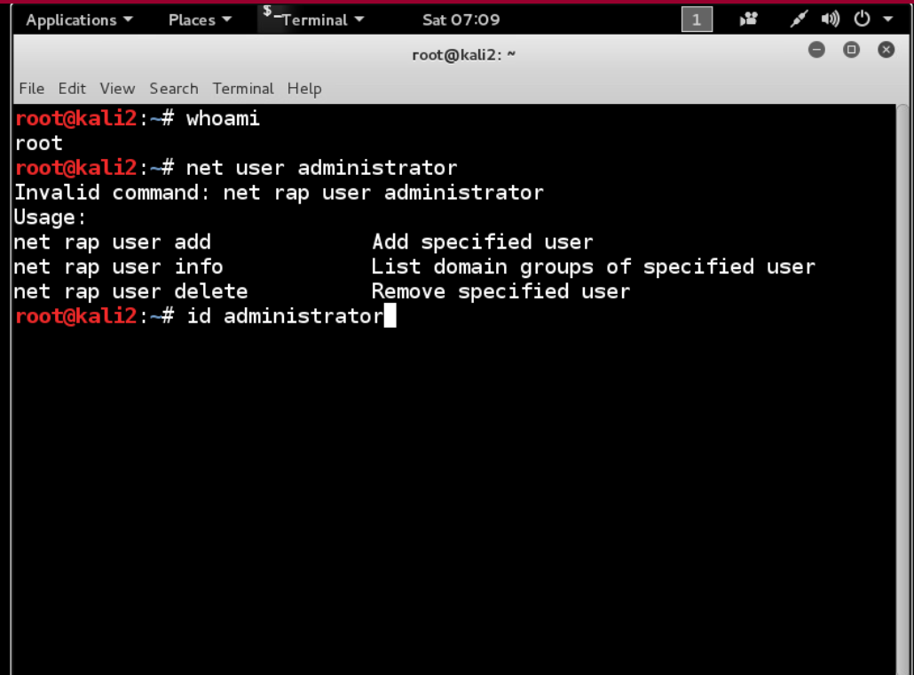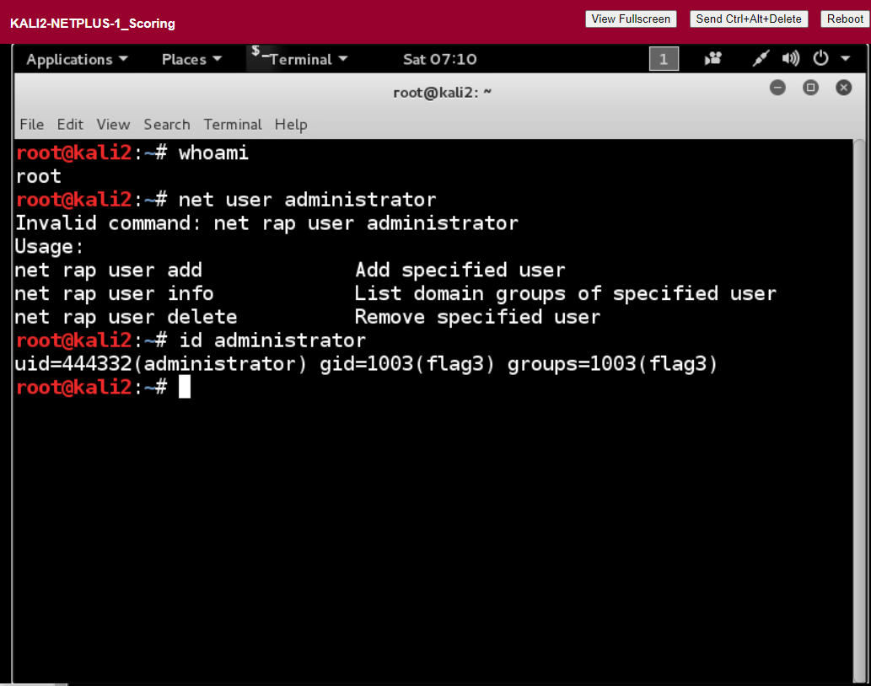challenged 3

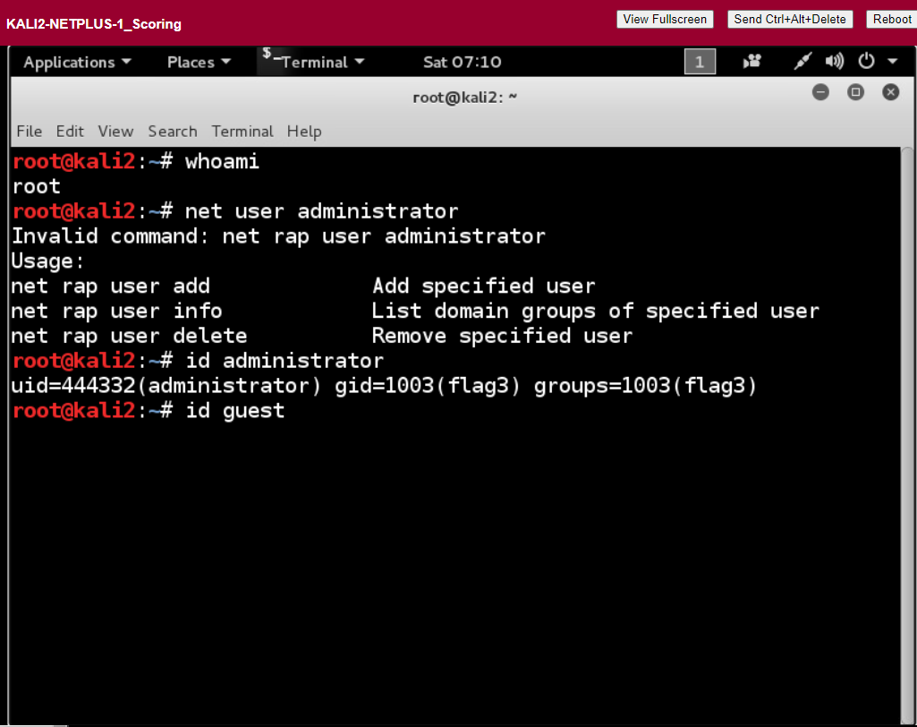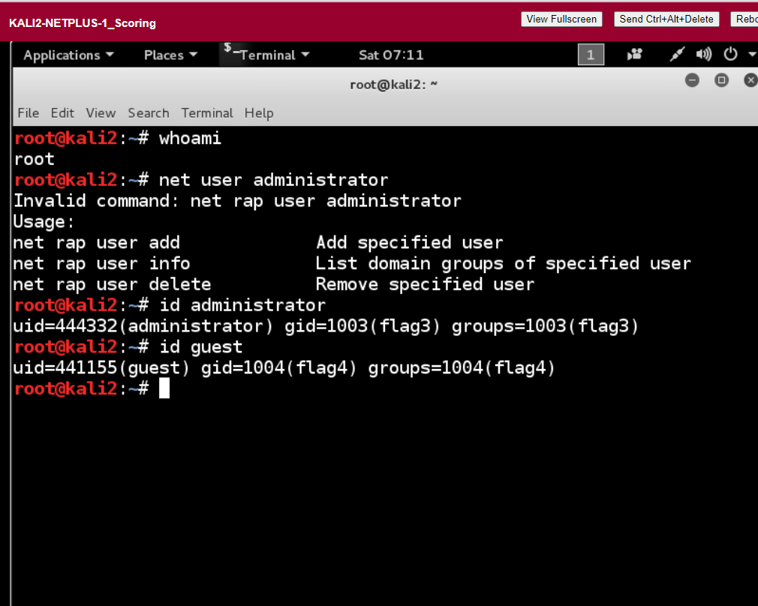challenge 4

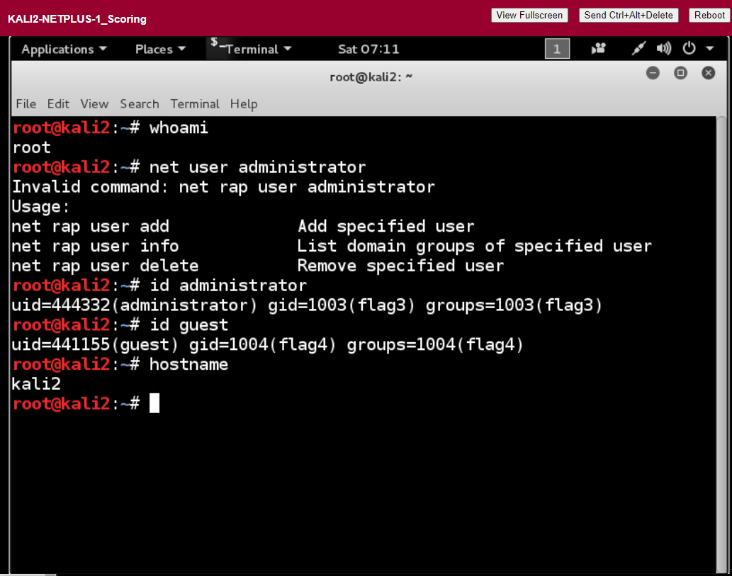What is the command used to display the current user in Windows and Linux? The command is whoami

What two commands can be used to obtain system information win Windows? Systeminfo and msinfo32.exe

What command can be used to display CPU information in Linux?

Cat /proc/cpuinfo

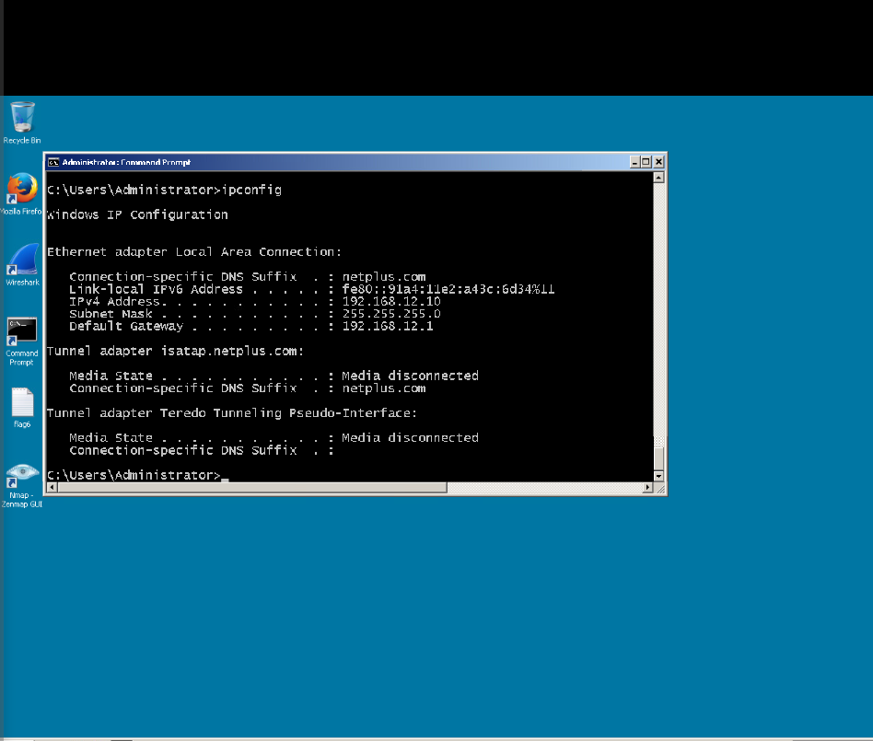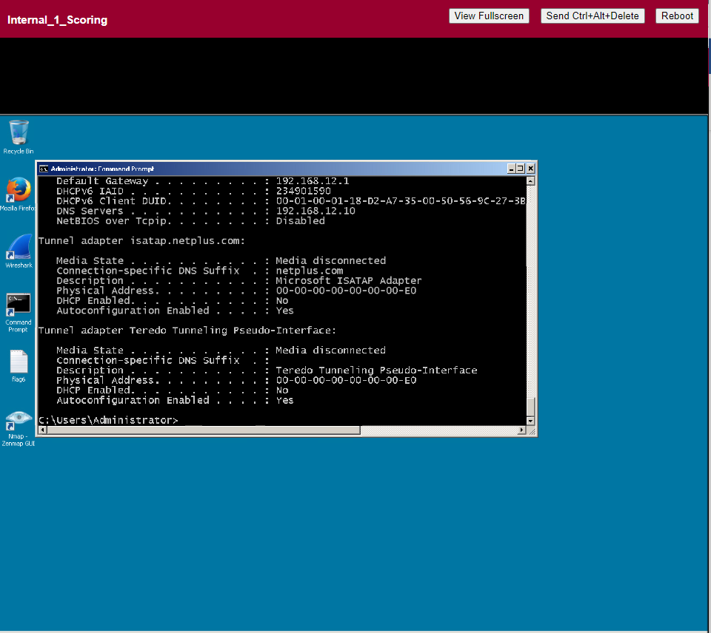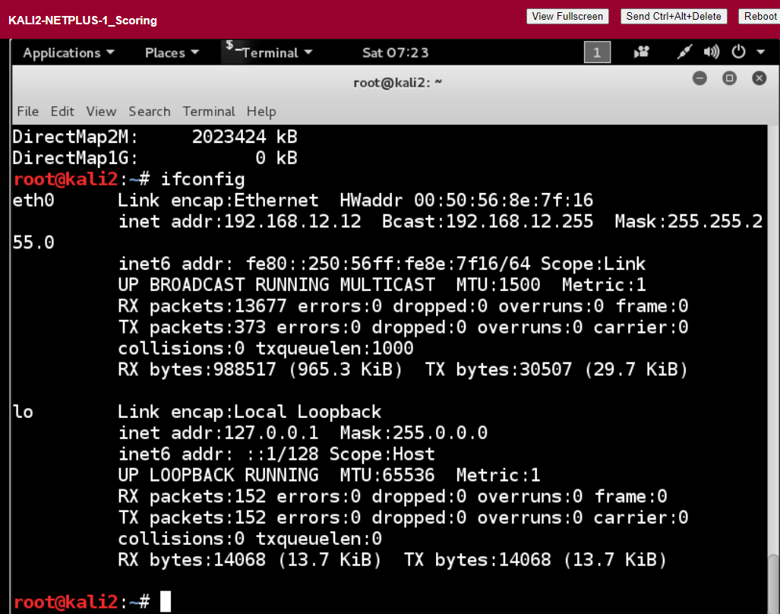challenge 5

Flag6 is 678891

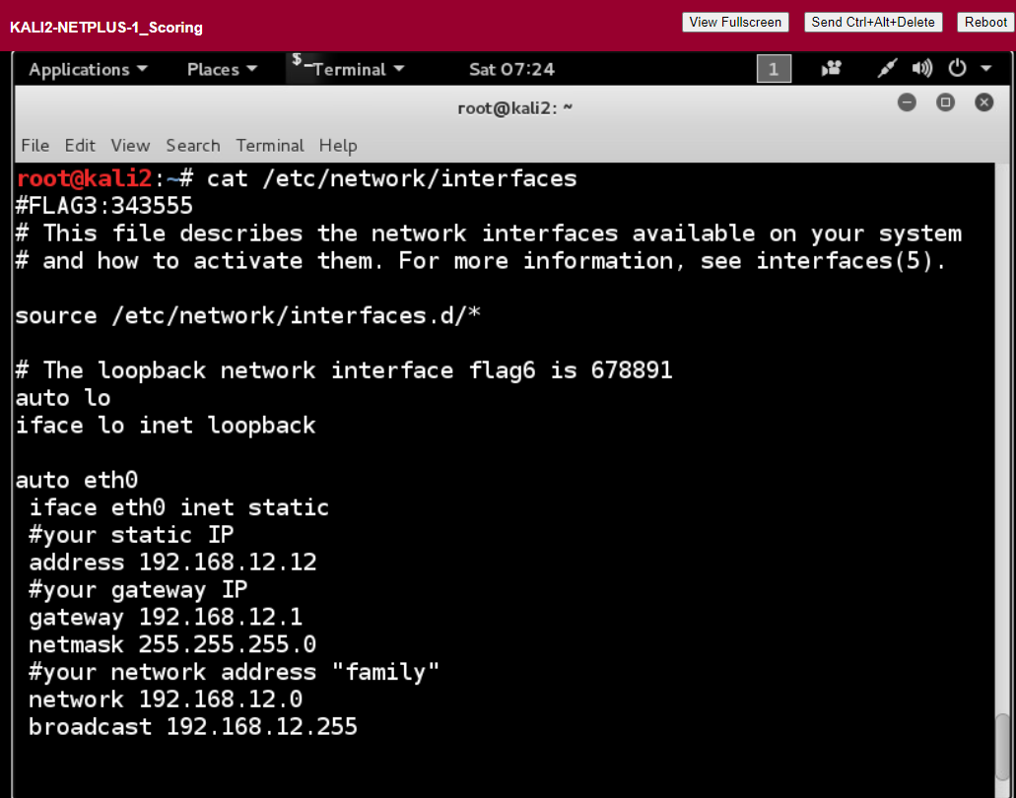What command can be used to display the IP address, subnet mask, and default gateway in Windows? ipconfig

What switch can be added to the above command to also view IP information such as DNS and DHCP servers? /all

What command can be used to display the IP address, subnet mask, and default gateway in Linux? Ifconfig

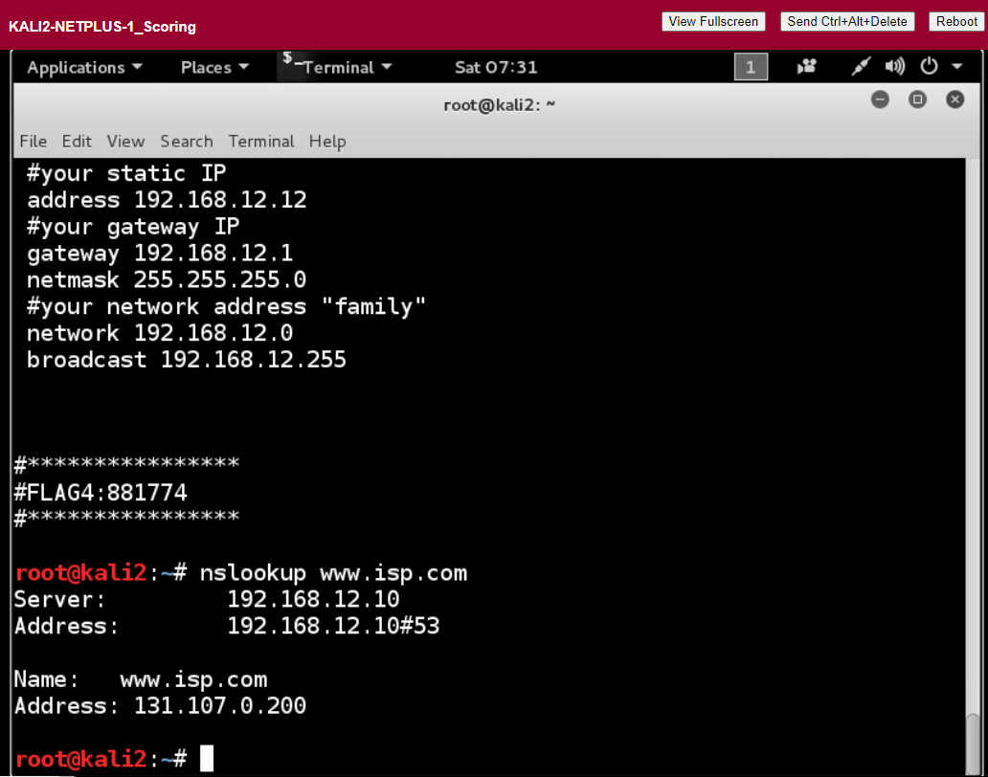What command is used to look up DNS information in Windows and Linux? nslookup

What two modes can the above command be executed in? interactive or noninteractive mode.

What special domain is associated with reverse DNS lookups? In-addr.arpa

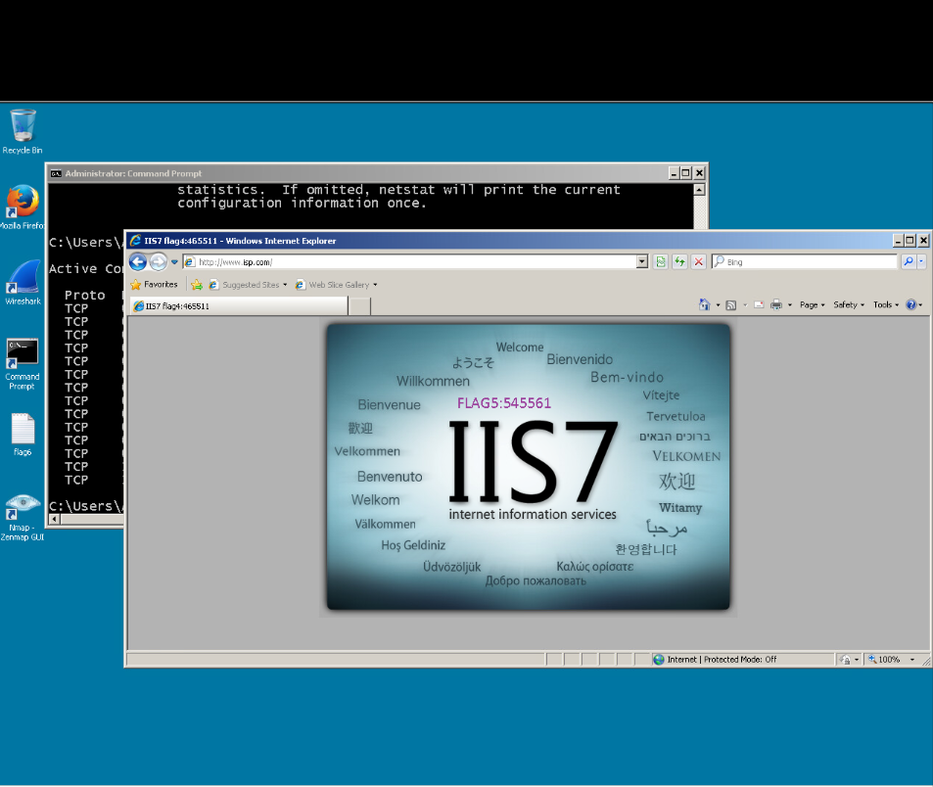What command is used to display connection information in Windows and Linux?netstat

What is at least one of the command switches for the above command that is the same between Windows and Linux and what function does it perform? -a

If a connection has been made to an available port, what state is that connection in? It is in an active state

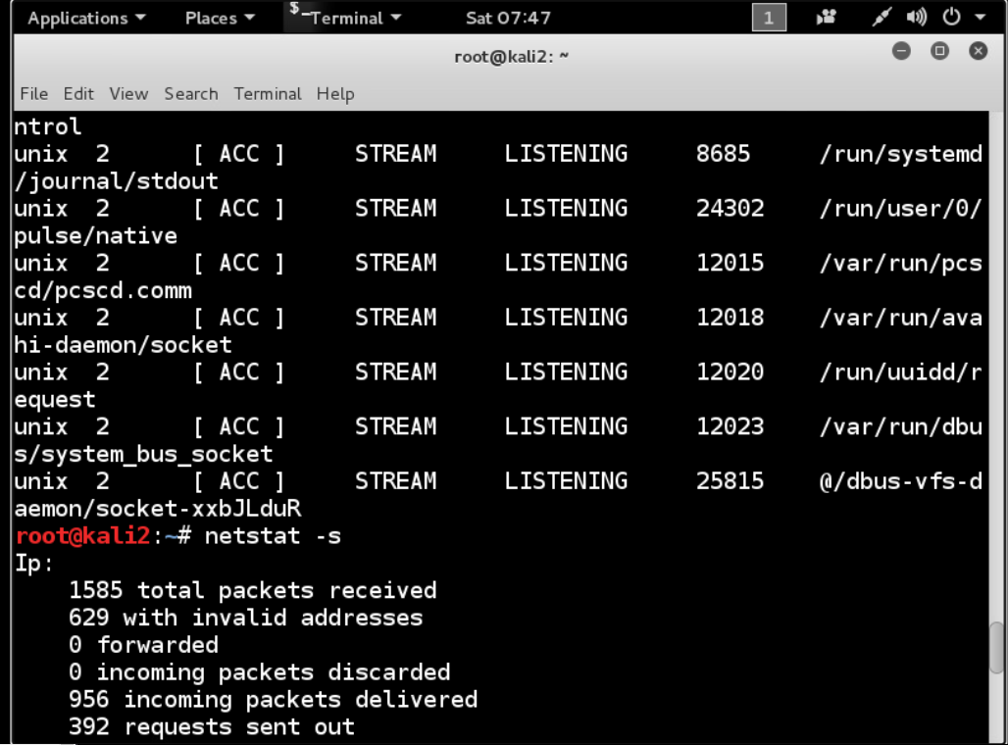

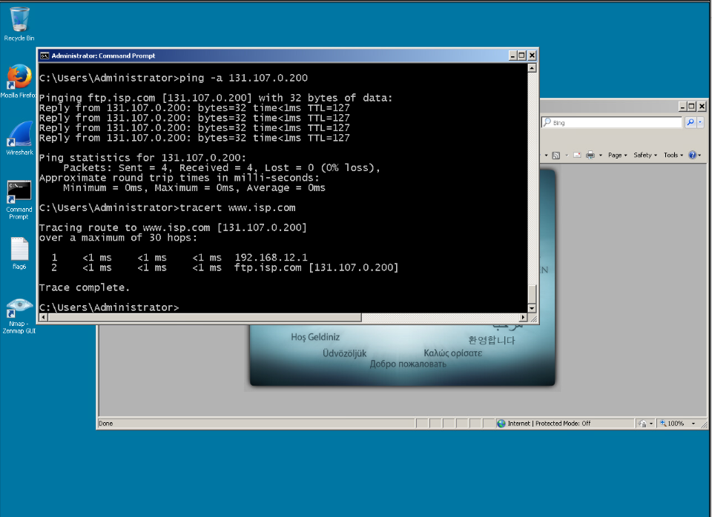

What command tests only end-to-end connectivity in Windows and Linux? Ping (insert address)

What command is used to test every hop between endpoints from a Windows machine? Tracert

What command is used to test every hop between endpoints from a Linux machine? Traceroute

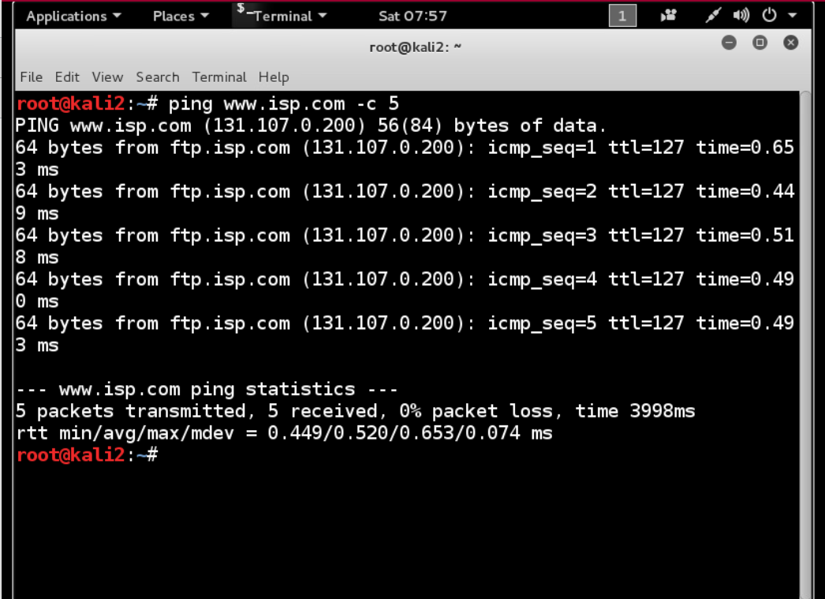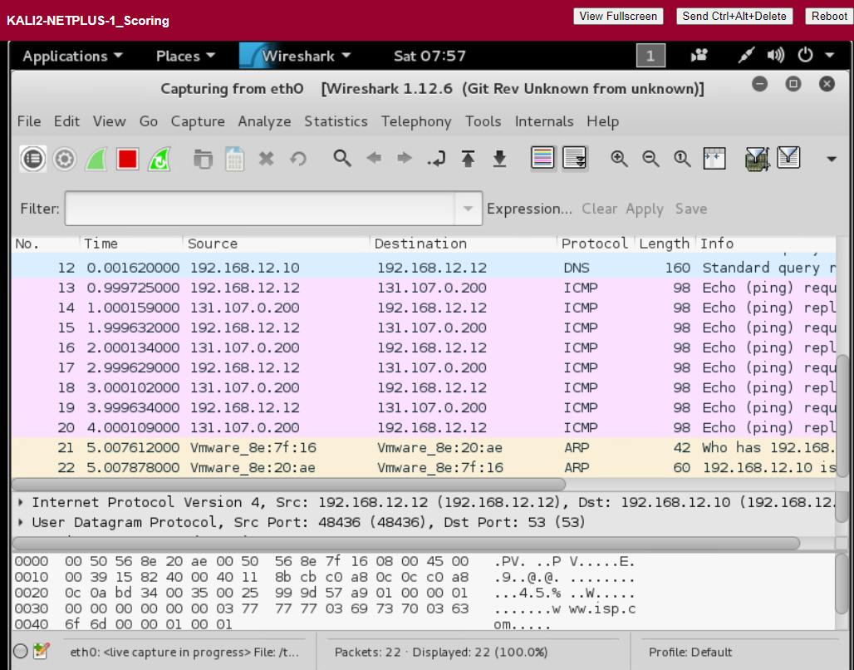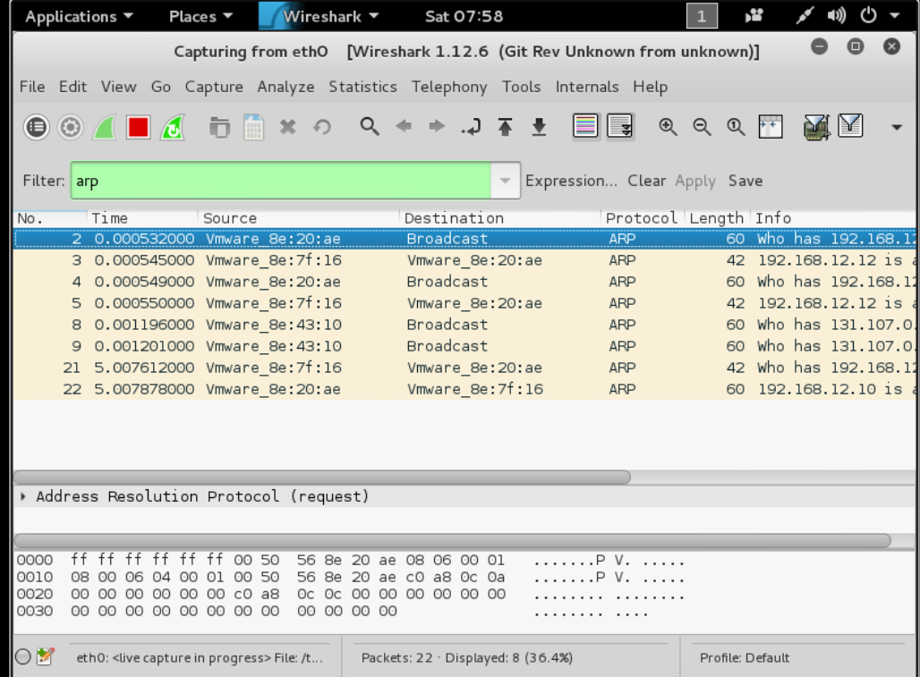The ARP protocol is used to determine what address of a node when what address is known? Mac address when the ip is known

What phase is the first half of the ARP process is known as? request

What phase is the second half of the ARP process is known as? Unicast reply